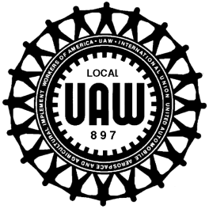

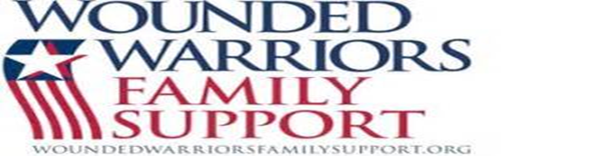
“YOU”
THE MEMBERSHIP RAISED & DONATED
$12,336.00
& “WE” THANK YOU!!!!

Dear Brothers and Sisters,
On behalf of President/Chairman; Dale E. Rogers, the Executive Board, the Veterans, Womens and Community Service Committees, we need to thank each and everyone of our generous members who donated and participated in all of the raffles these past 2 months in which we held to raise money for the Wounded Warrior Family Support.
Beginning with the 1st Annual Corn Hole Tournament, between the various sponsors from Blasdell Pizza, Bella Pizza, Sneakers, LongHorn Steak House, Corn Hole.com, West Herr Ford, Basil Ford and Towne Ford, all the donations and raffles, we raised $2,325.00. The Womens Committee Basket Raffle raised an unbelievable $4,000.00 and thanks everyone who donated basket items and participated in the raffle! The USA/UAW Calendars raised $1,665.00 and counting! The Retiree Chapter donated $265.00! There were several miscellaneous cash/check donations of $581.00! And lastly, our Region 9 Director Jeff Binz donated $1,500.00 on behalf of NJ CAP, PA CAP and requested $2,000.00 from UAW Internationl President, Gary Jones!!!
This Membership, ACTIVE and RETIRED, has proven time and time again, just how very generous and unselfish you all are when it comes to donating to those who are less fortunate than ourselves. We understand completely that you have your own families and finances to take care of and we know we ask quite a bit of you for charitable contributions from 50/50’s to raffles to Gate Collections but ……”YOU”.…… the Active and Retired Membership always come through NO MATTER WHAT! This is what SOLIDARITY and being UNION is all about! Make no mistake Brothers and Sisters, “WE” appreciate and value each and everyone of you!!!
Lastly, we wish to thank the entire workforce of all the employees at the Buffalo Stamping Plant for their overwhelming genorosity and contributing to all the various charitable fundraisers to support those in our community that have less than us! Your continous support shows how much we truly care about being an integral part of this Community.
In closing, please remember to keep all of our men and women sertving in the Armed Forces in your prayers. May God Bless each and everyone of us and the United States of America!
In Solidarity,
President/Chairman; Dale E. Rogers
Executive Board,
Veterans, Womens, & Community Service Commitee

