ATTENTION UAW MEMBERS IN GOOD STANDING

2019 Family Scholarship

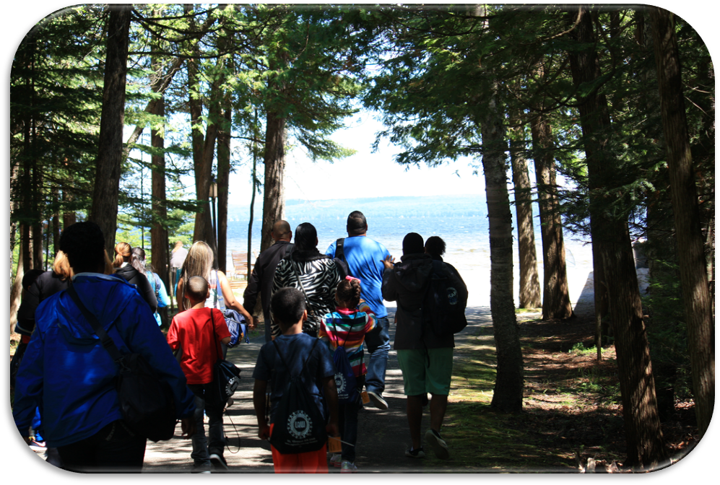

Walter and May Reuther UAW Family Education Center

Black Lake · Onaway, Michigan
July 21-26, 2019


This summer, introduce your family to a once-in-a-lifetime experience!

For more than 45 years, Black Lake has been a place where UAW members and their
families come together for an experience that combines education with relaxation.

It’s a place to learn about your union, unlock ideas and build new friendships with
other working families throughout the United States.

It’s a one-week summer experience that will leave you and your family filled with a spirit guaranteed
to strengthen your understanding and appreciation for your union.

Walter and May Reuther UAW Family Education Center Scholarship Program

FREQUENTLY ASKED QUESTIONS
Since 1970, thousands of UAW members and their families have participated in the Walter and May Reuther UAW Family Education Center Scholarship Program – changing their lives and those of their loved ones forever!
Located in scenic Onaway, Michigan on Black Lake, the Center was envisioned by legendary UAW President Walter Reuther to be a place where UAW members and their families could come together to learn and relax.
Through educational and recreational activities, the Family Scholarship Program provides an opportunity for adults and children to learn and think about how our union empowers us to change our workplaces and communities for ourselves and future generations.
These lessons are learned through daily adult and children’s programs and family activities. Below are the most frequently asked questions about the UAW Family Scholarship Program.
Who can participate in the program?
All active or laid off UAW members in good standing are eligible to apply for a Family Scholarship if you have never attended the program before. You must also be willing to use your regular vacation, personal leave or union leave time (where permitted by contract) to attend. Past participants are not eligible to reapply.
Your spouse and children/grandchildren 4-18 years old may attend with you. You may be required to provide a birth certificate or proof of legal guardianship for each attending child.
Children under 4 years old cannot be accommodated and other relatives, non-relatives and retirees are not eligible to participate – no exceptions!
What costs does the Family Scholarship cover?
The UAW pays all lodging, food and program costs for the entire one-week session. The scholarship does not cover costs for group photographs or other personal spending. Expenses for meals, tolls or other costs incurred during travel to and from the Center are also not covered.
What about transportation to the Center? How is that handled?
If you choose to drive, you must submit a $50 refundable registration fee. The $50 check is payable to “UBE, Inc.” Applications that do not include this refundable payment will not be processed. You will be reimbursed the entire registration fee upon completion of the program. If you choose not to attend the program and don’t notify the Center 10 days before your session, you will forfeit the registration fee.
If you choose to drive and you reside more than 500 miles one way (minimum 1,000-mile round trip), your mileage will not be reimbursed for the first 1,000 miles. After 1,000 miles, a driver will be reimbursed at the applicable IRS rate for each mile. Mileage is determined according to Rand-McNally and using the most direct route to the Center. Map Quest or other mileage charts will not be accepted for mileage calculations. When in doubt, contact your Regional Office. Additionally, on your trip to and from the Center, you will be entitled to one night of lodging when driving more than 500 miles and two nights when driving at least 1,000 miles. Motel rates should not exceed $65 per night for single occupancy or $80 per night for double occupancy. The Center will provide mileage and motel reimbursement upon completion of the program. Receipts are required for reimbursement.

Those who reside more than 500 miles one way from Black Lake can choose to fly to Detroit. You must be willing to have airline charges applied to your personal credit card. Upon completion of the program, you will be reimbursed, minus flyer fees as follows: $75 for the UAW member, $60 for the spouse, and $40 for each child. You will also be reimbursed for the cost of each attendee’s first piece of luggage. Receipts are required for all reimbursements.
The Center will make flight arrangements at least 15-21 days in advance of your session to take advantage of the lowest airfare. Airline registrations are done online. Once you have registered, you will be contacted by the travel agency. Be prepared to pay with a personal credit card. Personal checks are not accepted. Your Local Union may provide airfare payment; check with your Local Union in advance to determine whether such payment is provided. In cases where airline reservations are not made 15-21 days in advance, the International Union, UAW will refund only the cost of the lowest airfare. Airfare reimbursement will not be made to anyone not attending and completing the program.
If you fly, you will arrive in Detroit on Saturday, the day before your session starts. The Center will make hotel reservations for your Saturday night stay. The hotel information will be printed on the itinerary provided by the travel agency. Charter buses arranged by the Center will leave Detroit on Sunday at 9 a.m. (EST) and arrive at the Center around 3:30 p.m. For the Friday return trip to Detroit, no flight will be made before 5 p.m. (EST).
If I drive, what are the rules regarding vehicles?
Only North American/Union-Made vehicles are allowed to park on the Center grounds and must have a Vehicle Identification Number (VIN) beginning with 1, 2, 4 or 5. The VIN is located in the vehicle dashboard or door jamb. Upon arriving at the Center, security guards will check each car’s VIN. If your vehicle is not North American/Union-Made, you will be directed to park in a lot located adjacent to the Center’s front gate and a Center bus will transport you to the hotel registration desk.
What are the housing arrangements?
The Family Education Center consists of a main hotel and adjacent buildings with sleeping rooms and full bathroom and shower facilities. Soap, towels and all bedding is provided. Children are housed with their parents/grandparents. To maintain a family atmosphere, irresponsible behavior is not tolerated and may result in a family being asked to leave at their own expense.
Are pets allowed?
Pets are NOT allowed at the Family Education Center.
What is the typical daily schedule?
The entire family must participate in all scheduled programs from 8:45 a.m. to 4 p.m. The UAW member and spouse attend classes together while children/grandchildren participate in their own program which features age-appropriate learning and typical camp activities. A family activity is held after dinner most evenings and families are free to stroll on the beach, take a dip in the Center’s indoor pool or talk about the day.
Families have Wednesday afternoon “off” to explore the Center campus and nearby attractions, including the Black Lake Golf Course, Mackinaw City, St. Ignace, and Mackinac Island.
On Thursday evening of your session, an adults-only activity is planned while children participate in their own program in a supervised setting from 7 to 11 p.m.

Tell me more about the children’s program.
The children’s program is designed with the children’s age and grade they are entering in the fall to ensure age-appropriate lessons and recreational activities. Children’s groups are divided into: Pre-K to 1st grades, 2-5th grades, 6-8th grade and 9-12th graders. Teens 15-18 may participate in the adult program depending on the registration numbers for that week.
The youngest students in Pre-K to 1st grade learn in a playful environment with creative activities, music and games in the gym and at the beach. Elementary school students (2nd-5th graders) enjoy a variety of outdoor activities, including swimming, golf, gym and other recreational activities along with unique arts and crafts workshops. Middle schoolers (6-8th graders) will enjoy a schedule filled with Union Involvement workshops, along with golf, swimming and gym games. High school students (9-12th graders) will participate in a workshop that focuses on child wage and hour, and health and safety laws to inform them of their job rights and responsibilities.
Instructors are experienced union members who have been trained to work with children. All children will be required to sign a Code of Conduct form with their parent or guardian to emphasize responsible behavior while at the Center.
Will I need any special clothes?
Attire is informal and casual clothes are acceptable for classes and evening activities, though you may wish to pack additional items, Wednesday’s free afternoon and Thursday evening’s adult-only activity.

For more information about Black Lake visit: uawblacklake.com

/jr
opeiu494

2019 Family Scholarship Application
Fill out this form completely. The July 21-26, 2019 session begins on Sunday and ends on Friday. It is available in Spanish.

Legal FIRST Name: LAST Name:
Address:
City: State: Zip:
Local Union # UAW Region: Date of Membership:
Employed at: Location:
Home Phone: ( ) Social Security #: (Last 4 digits only)
Email: Age of applicant: Marital Status: Married  Single Male  Female 
Single participants not accompanied by spouse or children/grandchildren are roomed with another participant.
If spouse and/or children/grandchildren accompany UAW applicant to the Family Education Center, please complete the following:

Spouse’s Legal FIRST Name: LAST Name: DOB
List children’s complete LEGAL names, birth dates, grade in school child will be entering and sex:

First Name | Last Name | DOB | Grade entering | Male | Female

The Scholarship Program is open only to active UAW members’ children and grandchildren. Program is not open to other relatives or children under 4 years of age. For each child, you may be required to provide a birth certificate or proof of legal guardianship.

Please indicate any special needs of yourself/family members, i.e., disability or other medical condition:

Release of Photographs and Videos
I agree to allow the UAW to use my name and photograph and/or image in union publications, videos, advertising or brochures. I also agree to allow the UAW to use my child’s photograph and/or image in union publications, videos, advertising or brochures.

Both member and spouse must read and sign application:

UAW Member’s signature: Spouse’s signature:

▪ DRIVING: Attach $50 registration fee made payable to UAW Family Education Center. Applications received without registration fee cannot be processed.

▪ FLYING: No registration fee required. See “Frequently Asked Questions” to determine eligibility and actual costs of airfare.

If flying, once approved, your UAW Regional Office will provide you with instructions.
UAW Member: Application must be submitted to your Local Union
Local Union: Mail to UAW Regional Office

Applicant is a member in good standing with one year’s seniority.

______________________________________________
Local Union President or Financial Secretary

