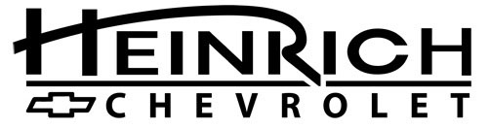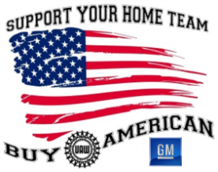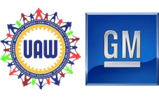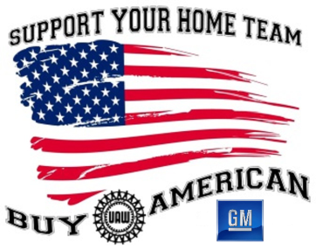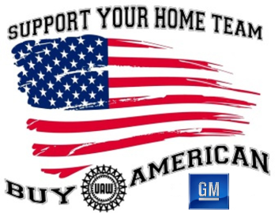

**Tonawanda Engine Builders**

**Kids’ Activities**

**Bounce House**

**Lots of Trophies**

**Dash Plaques & Goody Bags**

**For the first 200 cars**

**100’s of Cars**

**Remote Control Radio Car Races**

**50/50 Split**

**Basket Raffle**

***ALL ARE WELCOME***

American Cars, Trucks and

Bikes Only Please

***$15 donation to enter your car***

Proceeds to be donated to:

Sponsored By:

No glass containers or alcohol beverages

**Food Truck Rodeo**

John Cooper

(585) 813-7612

Co-Chairman

Mary Ward-Schiffert

(716) 622-1748

Chairman

**Car Show and Vendor Fair**

**Come see “The Warlocks” and “Circuit Stompers “**

**The Lockport and Newfane Robotics Teams and their robots**

***RAIN OR SHINE***

**GM Lockport**

**(Former Harrison Radiator)**

200 Upper Mountain Road

Lockport NY

**Saturday, August 26, 2017**

**9am-4pm**

**Music by**

**Hank Nevins**

**50’s 60’s 70’s**

Jessie Jesson

(716) 940-1951

Vendor Coordinator

Wayne Rider

(716) 474-7390

Car Show Contact

**19th BUY AMERICAN DAY & FAMILY DAY**

**UAW Local 686 Buy American Committee &**

**GM Components Lockport**