NAME | EMAIL | PHONE
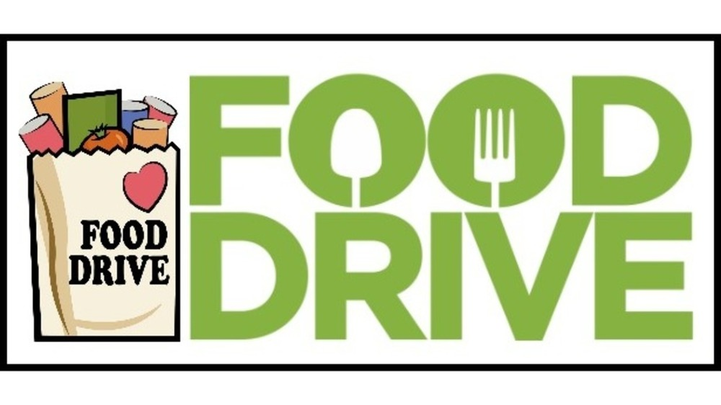


The UAW Community Service Committee needs drivers to help deliver Food Drive donations to
the Cornell Food Pantry. Details and dates to be determined.
If we do not have enough
volunteers, we will not be able
to host the Food Drive. All
items received will be donated to the Cornell Food Pantry.

