OFFICIAL CALL TO THE
2018 INTERNATIONAL UAW WOMEN'S
CONFERENCE
August 5 - 10, 2018
UAW Family Education Center
Onaway, Ml 49765
Cindy Estrada
Vice President and Director
UAW Women's Department
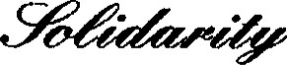BotcJe
8000 EAST JEFFERSON AVE.
DETROIT, MICHIGAN 48214-3963
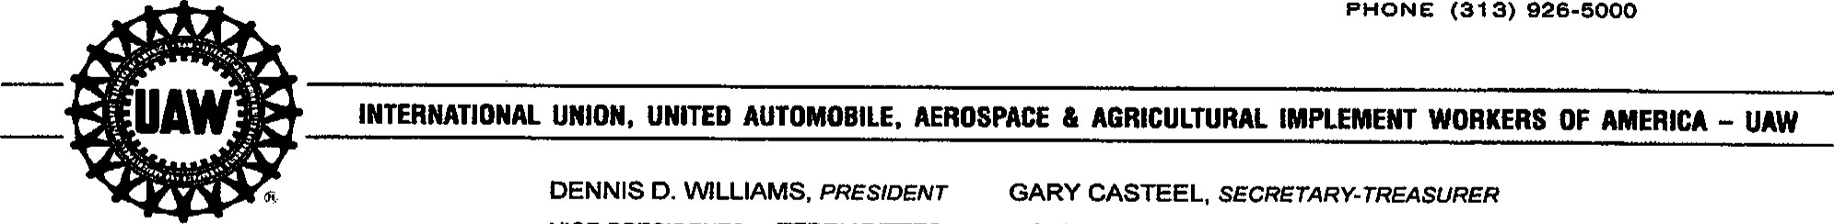PHONE (313) 926-5000
VICE.PRESIDENTS: TERRY orrres CINDY ESTRADA JIMMY SETTLES
Revised February 27, 2018
Greetings:
The 2018 International UAW Women's Conference will be held at the Walter and May Reuther UAW Family Education Center, August 5 through 10, 2018. Attendance is limited to delegates.
Registration of delegates will be held on Sunday, August 5, 2018 from 12 p.m. to 4 p.m. at the Lecture Hall.
The Conference will convene on Sunday, August 5, 2018 at 5 p.m. in the Lecture Hall and conclude on Friday morning, August 10, 2018.
The Local Unions are responsible for lost time and registration fees.
- Registration
Locals should send Conference registration checks or money orders to their Regional Office in the amount of $625 per delegate, payable to the International Union, UAW no later than July 13, 2018.
The Regional Office will forward all fees to the:
UAW Women's Department
8000 East Jefferson Avenue
Detroit, Ml 48214
Attention: Krista Szafranski
Please contact your Regional Office for further information on how to register and sign-up delegates for the conference.
- Transportation
Delegates whose worksites are located more than 500 miles from the Center (one-way) will be reimbursed travel expenses at the end of the conference as follows.
Driving: For those driving more than 500 miles one-way (1,000 miles round-trip) Mileage is not reimbursed for the first 1,000 miles of a round-trip. After 1,000 miles, a driver will be reimbursed the IRS rate for each mile. The International Union determines mileage according to Rand-McNally and reimburses for the most direct route to the Center. Do not rely on MapQuest or other Internet mileage charts.
On trips to and from the Center, delegates will be entitled to one night's lodging when driving more than 500 miles one-way; two nights' lodging for 1,000 miles or more. Motel rates should not exceed $65 per night for single occupancy; $80 per night for double occupancy. Delegates must save motel receipts and submit at the Center for reimbursement. Upon completion of the conference, delegates will receive mileage and/or motel refunds. Meals, highway tolls or other costs incurred during travel are not refundable by the UAW.
Note: Only North American/Union-made vehicles with Vehicle Identification Numbers that begin with 1, 2, 4 or 5 are permitted on the Center property.
Flying: For those flying to Detroit (Worksite must be more than 500 miles oneway.)
For those who choose to fly, the delegate will arrive in Detroit on Saturday, August 4, 2018. The Family Education Center will make hotel reservations at the Detroit Airport Courtyard, (734) 721-3200, for the Saturday night stay. That information will be printed on the e-ticket itinerary provided by the travel agency. The Detroit Airport Courtyard Hotel is a non-smoking establishment. A $200 fee will be applied to credit card if nonsmoking policy is violated.
Charter buses will begin loading at 8:30 a.m. and leave Detroit from the hotel Sunday at 9
a.m. (ET) SHARP. Arrival at the Center will be at approximately 3:30 p.m. For the Friday return-trip, no flights will be made before 4:30 p.m. (ET).
To take advantage of Super-Saver rates, all flight arrangements are made by the Family Education Center at least 14 days in advance. When contacted by TSI travel agency, be prepared to pay for airfare with either a personal credit card or through arrangements made with the Local Union. Local Unions may pay with a check or credit card. No personal checks will be accepted.
In cases of airline reservations not made 14 days in advance, the International Union will refund only the cost of Super-Saver fares. Meals, phone charges or other costs incurred during travel are not refundable.
Airfare reimbursement will be made upon completion of the conference. A $75 airline reqistration fee will be deducted from the reimbursement. The International Union will reimburse only the cost of a 14-day advance non-refundable ticket. Any changes, additional costs or late fees will not be reimbursed and is the responsibility of the Local Union or delegate.
We will be using the online airline registration process; please follow this LINK FOR ONLINE AIRLINE REGISTRATION: http://www.cvent.com/d/Otqx2q
-2-
All airline reservations must be made no later than July 13, 2018. Participants who fly must provide personal credit card information or a Local Union check for advance payment of their airline ticket.
Please allow 48 hours to process airline registration.
Luggage Reimbursement: For those who fly, the International Union will reimburse your 1 ^{st} piece of luggage each way. You must save your receipt and submit at the Education Office at Black Lake for reimbursement.
- Special FEC Delegates — Subsidy
Each Region is allowed to select five (5) delegates for a subsidy that will help reduce the cost of the conference. The subsidy covers the cost of housing ($285) and meals ($215) at the Center. Airfare or mileage is also reimbursed.
For a delegate awarded a subsidy, the Local Union or delegate is still responsible for any amount above $500, including additional registration fees or costs. Therefore, Special FEC deleqates will still be required to pav a $125 reqistration fee. Local Unions are responsible for lost time reimbursement. Along with the room/meal subsidy, a subsidized delegate will also be reimbursed for airfare, mileage, and motel expenses if they qualify. Subsidies will follow the above stated reimbursement guidelines.
- Cancellations
Cancellations must be submitted to the Regional Office at least 10 working days prior to the conference so that reservations can be reallocated. Refunds will only be granted for valid emergency reasons until July 20, 2018. No refunds will be given after July 20,
2018.
In solidarity,
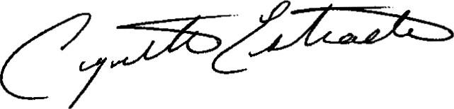
Cindy Estrada
Vice President and Director
UAW Women's Department
CE:dt
opeiu494
-3-

